King Fahd bin Abdul Aziz
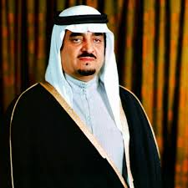
King Fahd received his basic education at the Princes School. He was very intelligent. His father, King Abdul Aziz sent him to represent the kingdom at many international conferences. King Fahd became the Minister of Education then the Minister of Interior Affairs and a Head of Ministers Assembly. In 1982AD, he was appointed King after the death of his brother, King Khalid. He carried the name of «The Custodian of the Two Holy Mosques». King Fahd established many Islamic projects. He laid the foundation stone to the last expansion of the Two Holy Mosques at Makkah and Madinah. King Fahd is known for his generosity. He never hesitates to help needy people and countries. He has a remarkable attitude in many Islamic and Arab matters specially the Palestinian case. King Fahd died in 2005AD.

English | Arabic | Pronunciation
King Fahd | الملك فهد | Almailk Fahd
Education | تعليم | Taleem
Princes School | مدرسة الامراء | Madrasat al'omara'
Intelligent | ذكي | Thakii
Minister of Education | وزير التربيه | Wazir altarbia
Minister of interior affairs | وزير الداخليه | Wazir alddakhilia
The Custodian of the two Holy Mosques | خادم الحرمين الشريفين | Khadim alharamayn alsharifayn
Projects | مشاريع | Masharie
Foundation stone | حجر الأساس | Hajar al'asas
Remarkable attitude | موقف ملحوظ | Mawqif malhuz
Palestine case | قضية فلسطين | Qadiat filastin

